

Mathematics Specialist Year 11

Student name: __________________________ Teacher name: ________________

Date: Monday 10 August 2020

Task type: Response + Investigation

Time allowed: 45 minutes (for the entire booklet)

Number of questions: 5

Materials required: Calculator with CAS capability (to be provided by the student)

Standard items: Pens (blue/black preferred), pencils (including coloured), sharpener, correction fluid/tape, eraser, ruler, highlighters

Special items: Drawing instruments, templates, notes on two unfolded sheets of
A4 paper, and up to three calculators approved for use in the WACE examinations

Marks available: 40 marks

Task weighting: 14% combined (8% for Test 2 and 6% for investigation 2)

Formula sheet provided: Yes

Note: All part questions worth more than 2 marks require working to obtain full marks.

Question 1 {1.3.4, 1.3.5} (4 marks)

- Let $x ϵ R.$Prove that that $x^{2}>x$is false by giving a counterexample. (1 mark)

- Disprove the following statement: There exists $x ϵ R$ such that $5+x^{2}=1-x^{2}$ (3 marks)

Question 2 {2.1.1} (5 marks)

Solve $2\cos\left(2(x+\frac{π}{3})\right)=-1$ given that $x∈\left[0,2π\right]$. Show your working.
Question 3 {2.3.4, 2.3.6} (7 marks)

Use mathematical induction to prove that that $4^{n}+6n-1$ is divisible by 3 for all $n∈N$

Question 4 {2.1.2} (8 marks)

- The function $f(x)=a tan (b(x-c))$ has been graphed below. Determine the values of the constants $a, b$ and $c$. (4 marks)
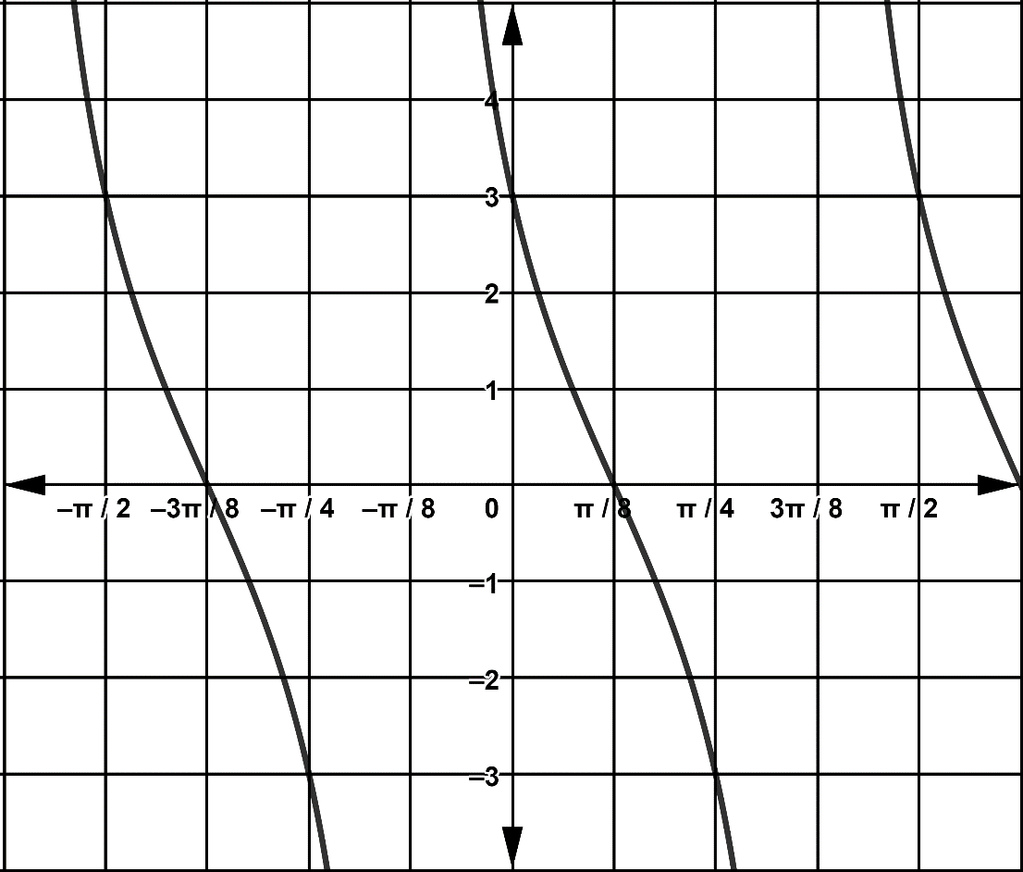

- Sketch the graph of $y=6 cos\left(\frac{1}{2}x+\frac{π}{4}\right) .$ (4 marks)
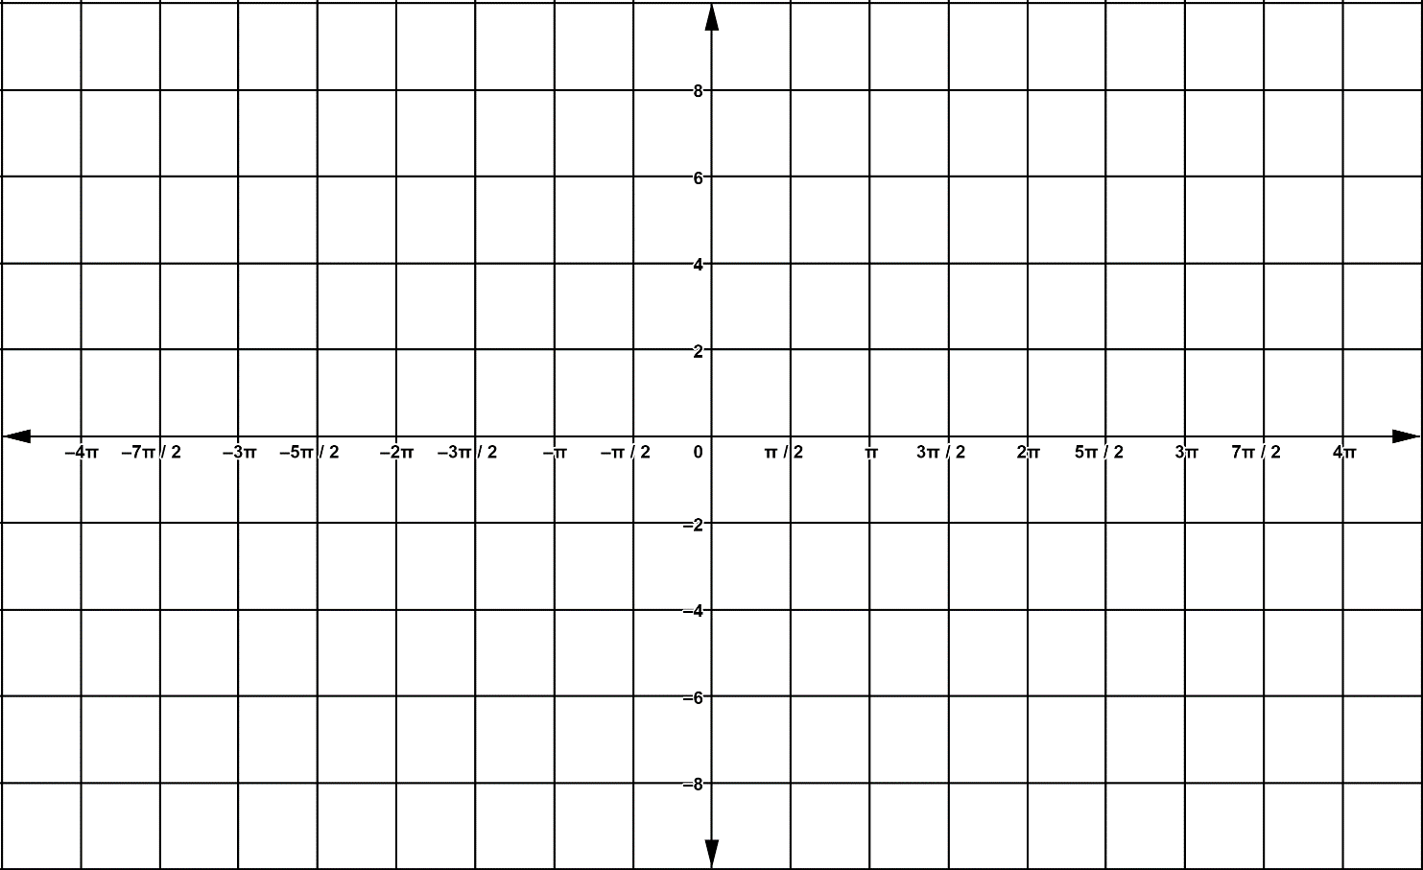

Investigation Validation {2.1.3, 2.3.4, 2.3.5} (16 marks)

- Use the identity
$$2sinAcosB=\sin\left(A+B\right)+\sin\left(A-B\right)$$
(or otherwise) to show that
$$2\sin{[x]}cos[(2k+1){x}]=\sin\left[2\left(k+1\right)x\right]-sin⁡[2kx]$$
(4 marks)

- Given that $\sin\left(x\right)≠0$ prove, by mathematical induction, that for all positive integers n,
$$cos(x)+cos(3x)+…+\cos\left[\left(2n-1\right)x\right]=\frac{sin⁡(2nx)}{2sin⁡(x)}$$
You may find the identity $sin\left(2A\right)=2sinAcosA$ useful.
(12 marks)

(additional working space)

